**July 4th App Storybook Photos and Captions**

**Storybook 1: GE/GDMS History**

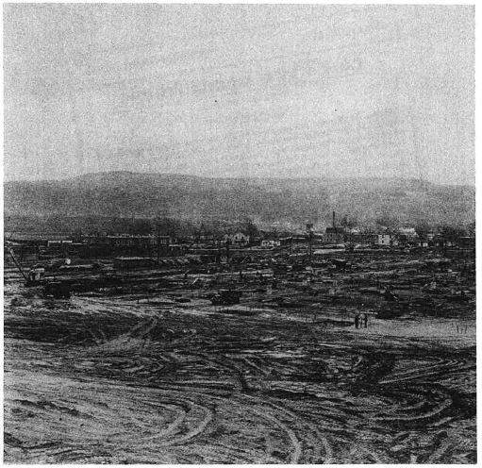

**Construction of Ordinance Plants Begin**

Caption: Excavation begins on Ordinance Place 1 and 2 on November 29th, 1940. The $1-million building was to become the first of three Ordinance Plants owned by the Navy and operated by General Electric. The three buildings were built specifically for the manufacture of gun directors for an expanding Navy Fleet during World War II.

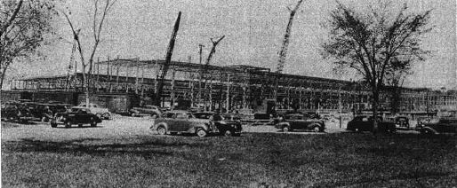

**Construction of East Plant #1**

Caption: By January 1941 the East Plant neared construction and by June 1941 the first employees were beginning to move in. By August 18th, 1941 the first manufacturing equipment was turned on and running. By February 1942 the first Navy inspector moved onsite. The first product constructed in Pittsfield was the Mk 37 Gun Director to be used on Navy Destroyers being built for World War II.

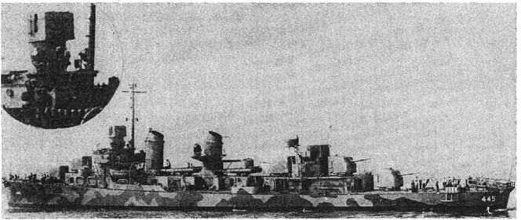

**USS Fletcher (DD-445)**

Caption: By April 28th, 1942, the first gun director was shipped to the USS Fletcher (DD-445) which was undergoing final phases of construction before launching on June 1st, 1942. The Pittsfield facilities expanded to include two new buildings for production including producing 5,000 horsepower GE marine synchronous motors for use on high-speed escort vessels to fractional horsepower motors.

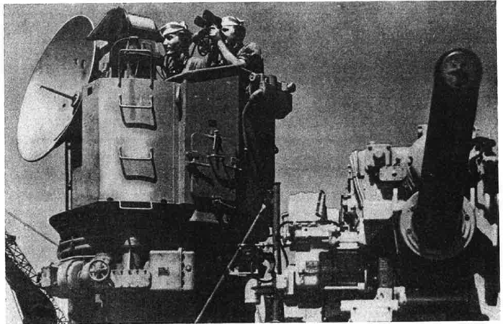

**Mk 56 Gun Director**

Caption: By the end of WW2 production shifted to supporting peace time development. From 1948 to 1953, and through partnership with GE Aeronautic and Marine Division in Schenectady, New York, and MIT in Cambridge Massachusetts, production would expand to include the Mk 56 Gun Fire Control System as the first completely integrated automatic radar tracking and fire control computer system. This new production coincided with constructing Ordinance Plant #3 off of Merrill Road for the purpose of testing the Mk 56.

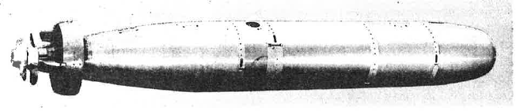

**Mk 35 Mod 1 Torpedo**

Caption: During the same period, Ordinance Plant #1 switched to producing the Mk 35 Mod 1 Torpedo. By 1951 production of the Mk 35 was also completed at East Plant #2.

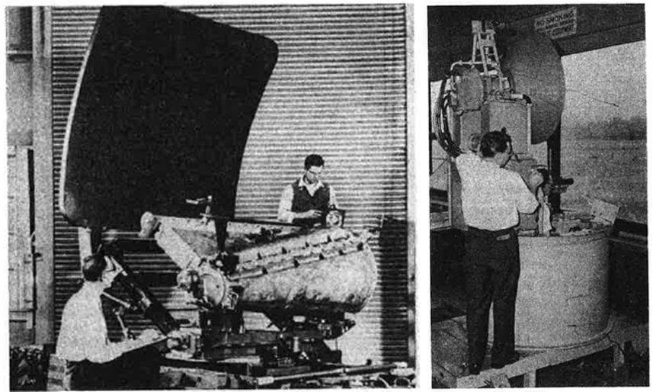

**Left to Right: MPQ-4 Mortar Locator and Mk 75 Gun Fire Control System**

Caption: By 1954 procurement strategies by the U.S. Military changed. The Military began to buy major systems on advanced concepts and as a result production slowed with the majority of the work switched to the engineering of advanced systems. Two of these systems were the MPQ-4 Mortar Locator and Mk 75 Gun Fire Control System. Additional new products built at GE Pittsfield included antennas for radio systems, a new Mk 44 Torpedo, and the Mk 12 Guided Missile Launcher for the Navy’s Talos missile.

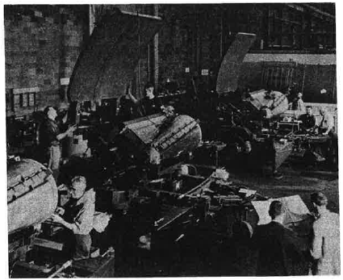

**MPQ-4 Assembly Area**

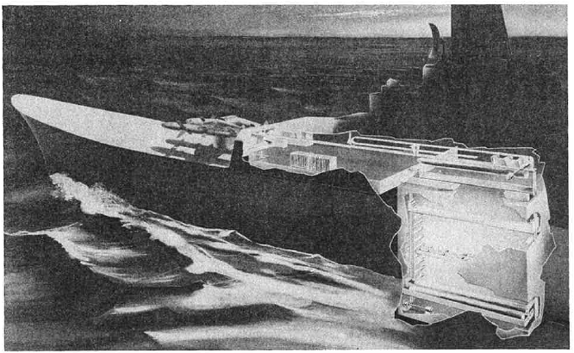

**Handling System for Navy’s Talos Missile**

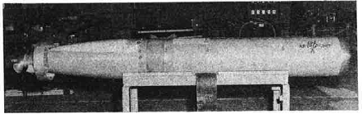

**Mk 44 Torpedo**

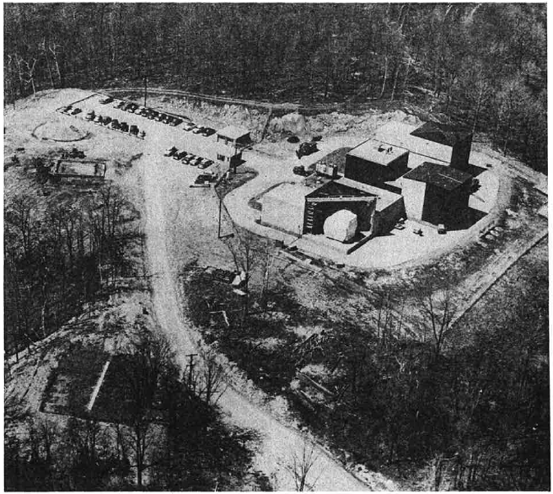

**Hancock Ordinance Facility**

Caption: By June 1955 GE announced the reorganization of its electronic business and the Naval Ordinance Department of Pittsfield was merged with the Special Defense Projects Department out of Philadelphia, Pennsylvania. As a part of this reorganization GE constructed the Hancock Ordinance Facility on Apple Tree Hill in Hancock, Massachusetts to assist the development, assembly, and testing of the Atlas ICBM Tracking Antenna. The plant officially opened on April 1st, 1957 and employed about 50 GE personnel.

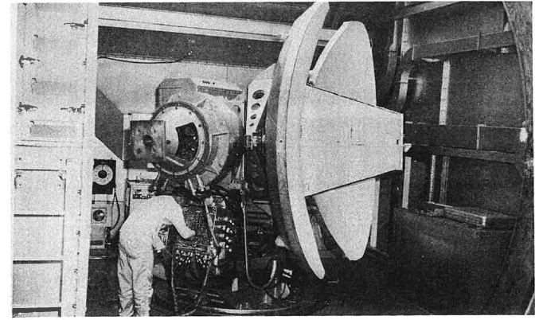

**Missile Guidance Antenna for Atlas ICBM**

[INSERT SOME POLARIS PHOTO]

Caption: Following the reorganization in 1957, The Pittsfield Ordinance Equipment Section began expanding again adding additional office and laboratory space needed for more engineering personnel. The expanded space was to support the recently transferred Polaris Missile program from Philadelphia. This included the program as well as about 86 engineers and technicians from Philadelphia with work primarily occurring in Ordinance Plant #1 and #3. Official production began in 1958 for the Polaris guidance and fire control systems used in the Polaris missile. The missile would go onto have its first successful launch with Pittsfield equipment in July of 1960.

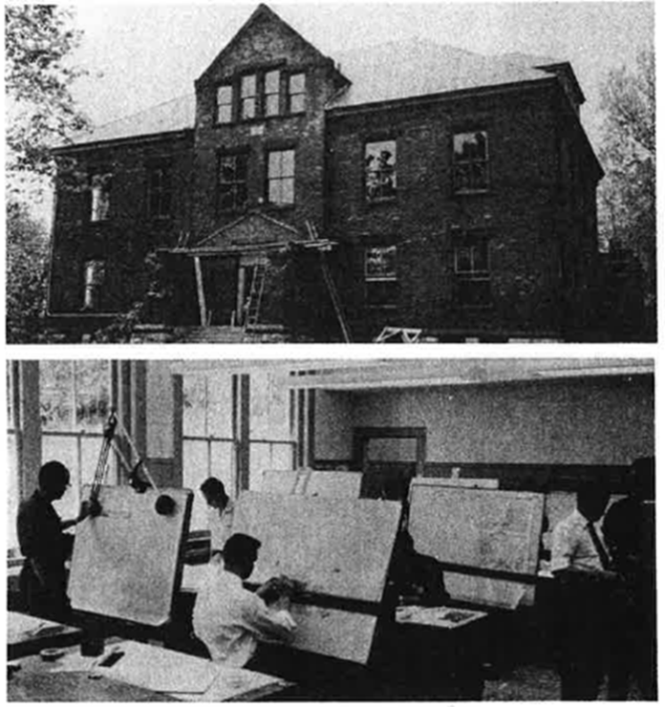

**Craneville School**

Caption: By 1959 business continued to expand at GE Pittsfield at an accelerated pace. The expanding engineering group led to expansion to other locations including the former Craneville Elementary School on Main Street in Dalton, Massachusetts. This site included about 65 drafting personnel and the site was renamed as Ordinance Plant #7.

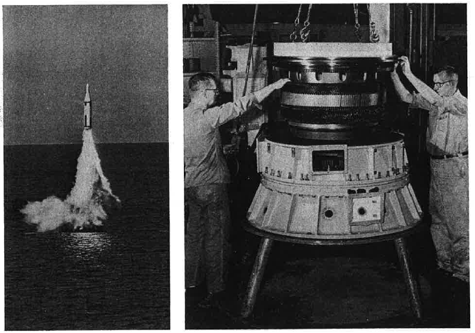

**Left to Right: First Successful Polaris Launch and the Mk 73 Gearless Power Drive**

Caption: 1960 saw several important program milestones, contract wins, and further building expansions. On July 20th, Polaris had the first successful launch of a live missile from the submerged USS George Washington. In September of 1960, the GE Ordinance Department announced the win of three contracts including $2 Million for new Mk 73 Gun Directors to be used on new Navy Guided Missile Destroyers. A second contract for $1.4 Million was awarded for the construction of seawater batteries used for the Mk 44 Acoustic Homing Torpedo. The third contract awarded was for $1 Million of new Mk 44 Torpedo construction. Later that year the Talo Mk 12 was installed upon the nuclear powered USS Long Beach Cruiser for the first time.

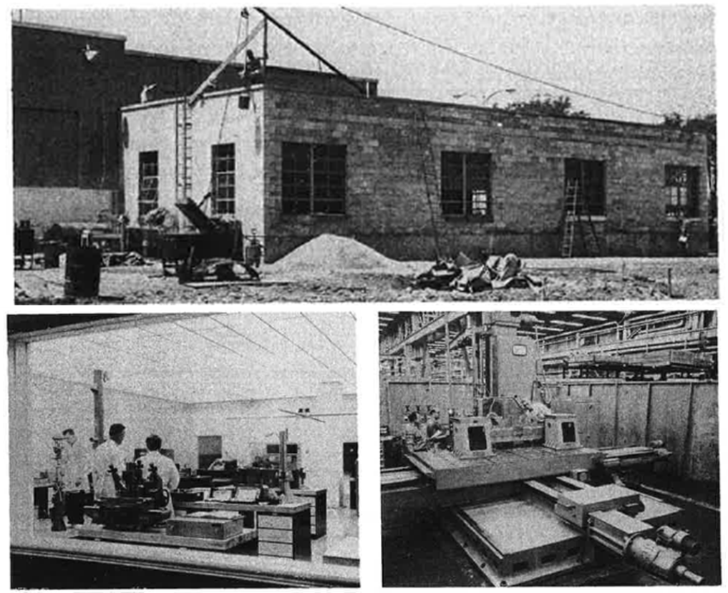

**Top Picture: OP-3 Building Expansion, Left Picture: Meteorology Lab in Op-3, Right Picture: Numerically Controlled Horizontal Boring Mill in OP-3**

Caption: Building expansions during 1960 took over several spaces in Pittsfield. Space at Craneville School was expanded to three floors and the new space was occupied by personnel from Light Military Electronics Department, Utica, New York. In June, a lease was signed for the former Nugent School and in July, the Product Service unit moved in. About 135 people from GE Finance, Technical Publications Operation, and non-Polaris purchasing moved into the Berkshire Life building at 7 North Street in September. And in December, a new east wing of 13,000 square feet, was constructed at Ordnance Plant #3.

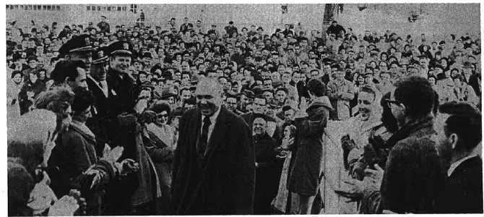

**Departing General Manager Gerald A. Hoyt**

Caption: GE Pittsfield in 1960 also saw the departure of General Manager Gerald A. Hoyt who was first appointed in June 1956. On January 25th, 3,000 Ordinance Department employees honored the departing General Manager by holding a mass spurof-the-moment demonstration. News was passed by word of mouth and the crowd was so large that it completely blocked Plastics Avenue.

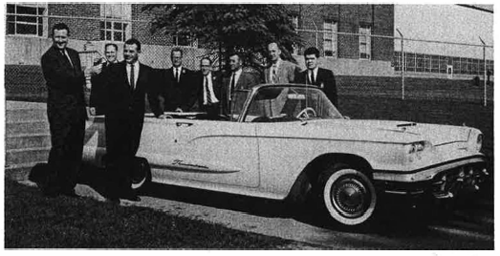

**“Break-Thru 60” Thunderbird**

Caption: A Thunderbird was delivered to GE Pittsfield in June 1960 in honor of the division’s savings of more than 1.5 million dollars in the first quarter of the “Break-Thru 60” program. Since the Thunderbird was only staying on site for a month, a plan was worked out by drawing names from outstanding contributors. Each winner picked up the car shortly before quitting time and returned it the next morning.

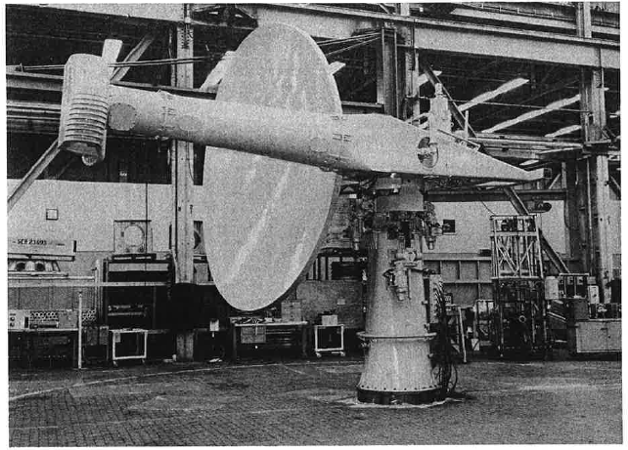

**Pre-Production Model of SPS-30 Antenna**

Caption: GE Pittsfield in 1961 saw additional contract wins including a $36 million contract to produce the Navy’s new AN/SPS-30 shipboard height-finding radar, GE’s first space program contract for shipboard communication antennas on satellites called ADVENT, and a contract for a high precision aiming reference system for a 600-foot radio telescope at the Naval Research Station in Sugar Grove, West Virginia.

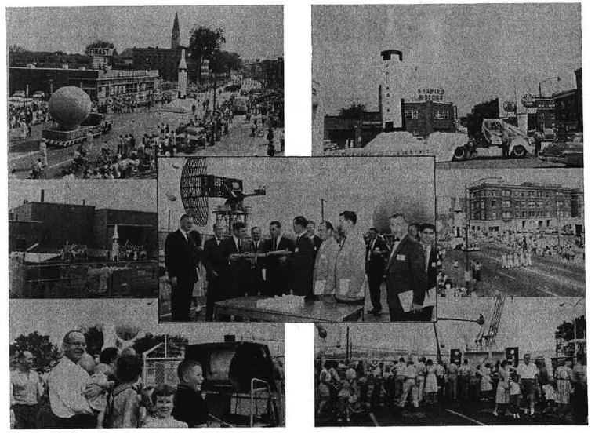

**Berkshire County-Pittsfield Bicentennial Celebration**

Caption: The Berkshire County-Pittsfield Bicentennial celebration was held on Saturday, September 2nd, 1961. As a part of the celebrations the GE Ordinance Department held an open house at Ordinance Plant #3. A 30-foot, full-scale replica of the Polaris missile was featured as well as many other exhibits of Ordinance Department products. More than 9,000 people attended.

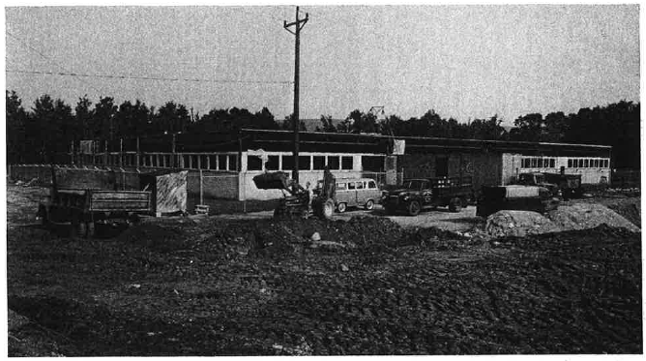

**Ordinance Plant #8 in Dalton, Massachusetts**

Caption: With Polaris work expanding, GE Pittsfield expanded yet again to a new building built in Dalton, Massachusetts. On October 2nd, 1961, 250 employees moved in. The new building became the Guidance and Electro-optical Engineering Building but was referred to as Ordinance Plant #8. The building focused on engineering work for guidance and electro-optical products of the Polaris missile.

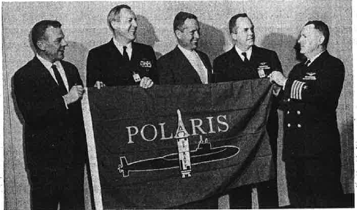

**GE General Manager Accepts Polaris Flag from the US Navy Fire Control and Guidance Branch Head for the Navy’s Special Project’s Office**

Caption: On April 29th, 1964, the GE General Manager was given a Polaris flag “as a badge of membership in a unique and vital team dedicated to the defense of our country and the preservation of peace”. Later that same year in June, GE Ordinance in Pittsfield was awarded a $4 million contract for continued production of the Mk 2 Polaris Guidance Gimbal Assemblies.

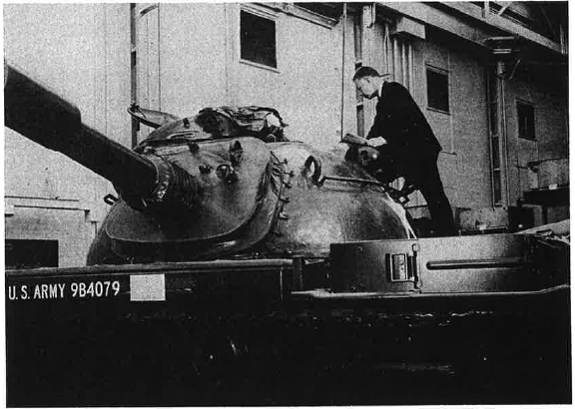

**A M-60 Tank loaned to GE is Inspected at the Pittsfield Site**

Caption: In January of 1965, Pittsfield Ordinance began working on the Optimum Ratio Stabilized Power Drive for vehicle mounted gun fire systems. An M-60 Tank was loaned in April 1965 for the purpose of installing and evaluating an engineering model of the Power Drive. A test range was constructed behind Ordinance Plant #3 to assist in this.

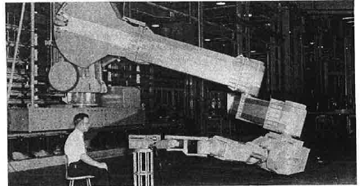

**Demonstration of the Nuclear Engine for Rocket Vehicle Application (NERVA) Robotic Arm**

Caption: InApril 1965, Pittsfield Ordinance Department arranged a series of demonstrations showing NERVA picking up a small weight from a box and putting it on the floor. This was all done through remote control. Two of these units were designed and built to work on “hot” atomic engines at a NASA facility in Nevada. The program was eventually transferred to GE’s Research and Development Center in Schenectady, New York.

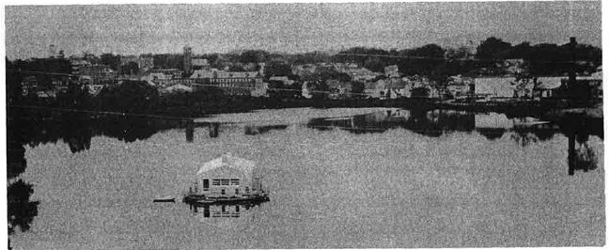

**Floating Laboratory on Silver Lake, Pittsfield, MA**

July of 1965 saw the construction of a 72-foot Float Laboratory on Silver Lake for use in conducting underwater acoustical tests for the US Navy.

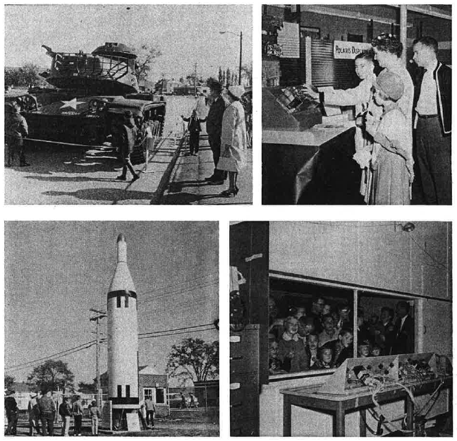



**GE Family Day, October 2nd, 1965**

Caption: GE Family Day was held on October 2nd 1965 and saw various sights and activities for GE Family members. A life-size Polaris prototype missile was loaned from the Portsmouth New Hampshire naval yard by Navy officials. An Army Tank was also parked in front of the main entrance on Plastics Avenue. At Ordinance Plant #1, visitors pushed buttons simulating a missile firing. At Ordinance Plant #2, visitors saw the Mk 73 Missile Director in action as well as various other product displays. Ordinance Plant #3 showcased precision machining, the super-clean room, and the Polaris missile guidance package.

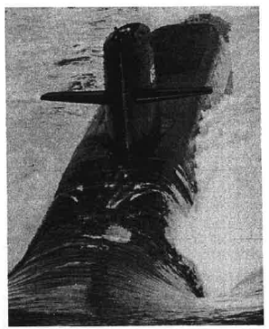

**USS Will Rogers**

Caption: 1966 saw the launching of the last Polaris Submarine, the USS Will Rogers, on July 21st. The submarine was the last of the scheduled 41 nuclear subs capable of launching Polaris missiles. Pittsfield Ordinance Department fire control and guidance systems and support equipment played a major role in the 10 year Polaris Program.

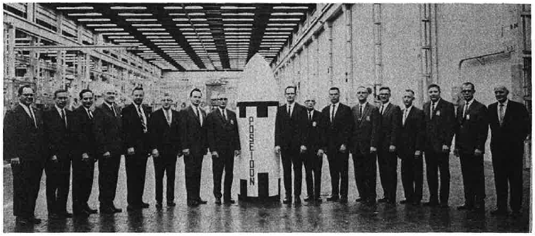

**End of the Polaris Hardware Program**

Caption: In October and November of 1966, the last Mk 2 guidance system and Mk 84 fire control system were completed which marked the end of the Polaris Hardware Program. GE veterans of the program gathered for a 10-year anniversary photograph with a scale-model mock-up of the emerging Poseidon missile systems.

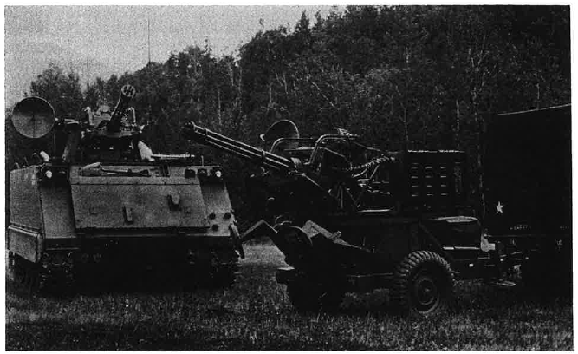

**Vulcan-Armed Light Tank M163**

Caption: September of 1967 saw the shipment of the first gun turret for the Vulcan-Armed light tank M163 VADS. Pittsfield Ordinance provided manufacturing support for the Vulcan Air Defense System since 1966.

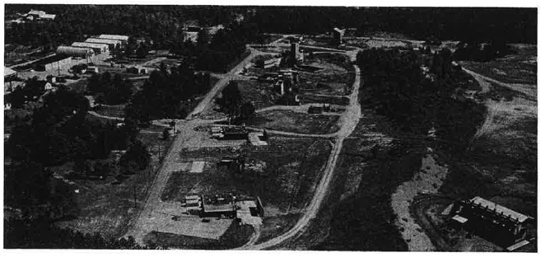

**Malta Test Site**

Caption: 1968 saw further expansions and program wins by Pittsfield Ordinance, such as a contract for the design, development, and installation of training facilities for the Navy’s new Poseidon Weapon System. By March, Pittsfield Ordinance had transferred all work done at the Malta Test Site in New York to Pittsfield Ordinance. The Malta teams had been involved in the research, design, and fabrication of new military technologies such as liquid rocket engines and nuclear industry services.

[Insert Poseidon Missile Picture]

**First Flight of the Poseidon Missile**

Caption: August 1968 saw the first launch of the Poseidon missile from a land pad at Cape Kennedy.

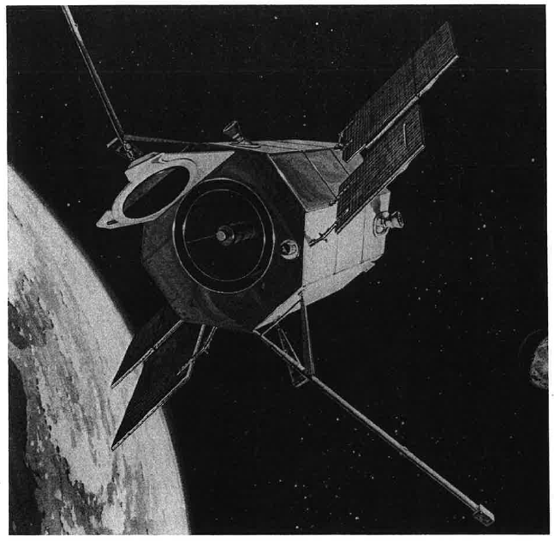

**Orbiting Astronomical Observatory (OAO-2)**

Caption: On December 7th, 1968, the OAO-2 was launched from Cape Kennedy aboard an Atlas-Centaur. The OAO-2 carried attitude reference systems designed and built by Ordinance Systems.

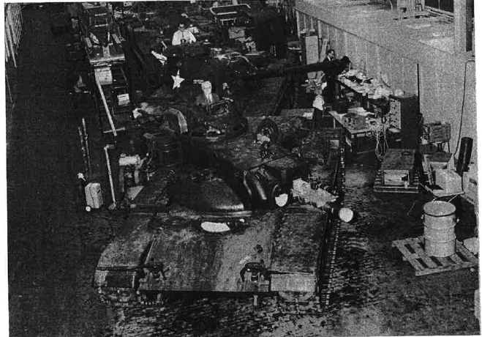

**M60A1E2 Optimum Ratio Stabilized Drive**

Caption: February 1969 saw the delivery of a new Stabilized Drive for US Army tanks. Tanks installed with the drive left Pittsfield and were tested at the Army Proving Ground at Aberdeen. Earlier testing was conducted at the course behind Ordinance Plant #3.

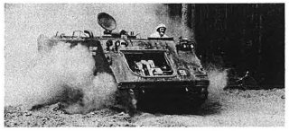

**M113A1 Armored Personnel Carrier**

Caption: June 1970 saw the completion of a 10,000 mile test on rough terrain with a Pittsfield developed mechanical transmission. The transmission was installed in an M113A1 Armored Personnel Carrier and was conducted at the Malta Test site. The round-the-clock road test was an outstanding performance and fulfilled a contract with the U.S. Army Tank Automotive Command.

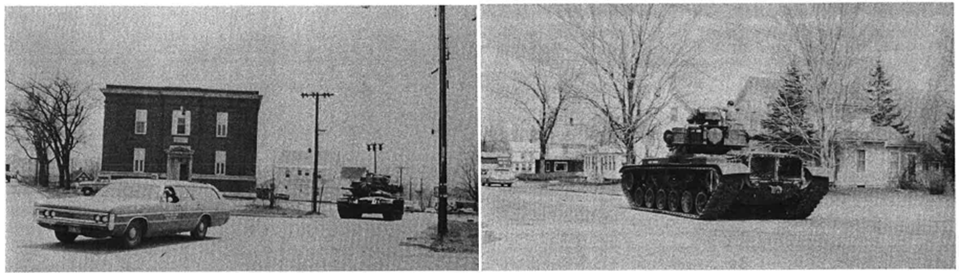

**M160A1E2 Tank on Merrill Road**

Caption: A M160 tank was delivered to Pittsfield in May 1971 for the purpose of an engineering study to modify the tank’s fire control system. The photo above shows the tank arriving at the Pittsfield facility after taking a drive down Merrill Road.

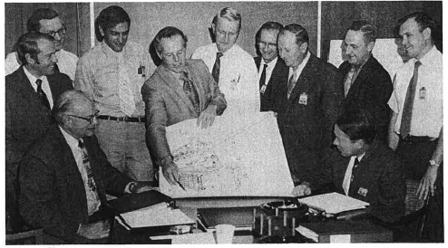

**Mk 45 Naval Artillery Contract**

Caption: 1971 also saw a new $46 million contract awarded to Ordinance Systems for 54 Mk 45 Naval Artillery gun mounts. The contract represented a huge win as it made Ordinance Systems the lead on the project over competitors who had developed the first 25 systems. The picture above showcases part of the team involved with the contract.

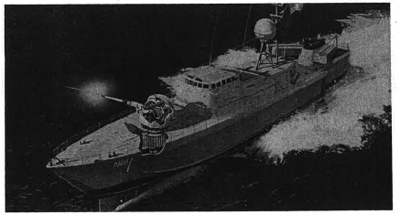

**Italian 76-mm Naval Gun**

Caption: The Mk 45 contract win in 1975 positioned Ordinance Systems into a new market. In 1972 Ordinance Systems reached an agreement with an Italian company to produce 76-mm gun mounts for Italian ships.

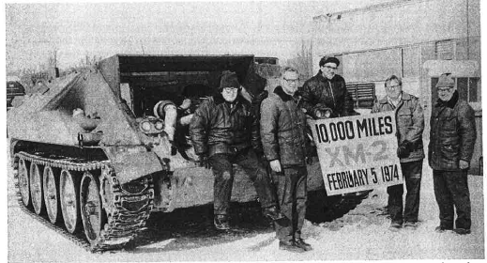

**Mechanized Infantry Combat Vehicle (MICV)**

Caption: February 1974 saw another exciting event. Ordinance Systems completed a 10,000 mile durability test on the Aberdeen test course behind Ordinance Plant #3. The test was testing an Ordinance Systems transmission installed on the US Army’s Mechanized Infantry Combat Vehicle (MICV). The test was notable for the fact that it was conducted in minus 5-degree weather and was completed at 3:00AM.

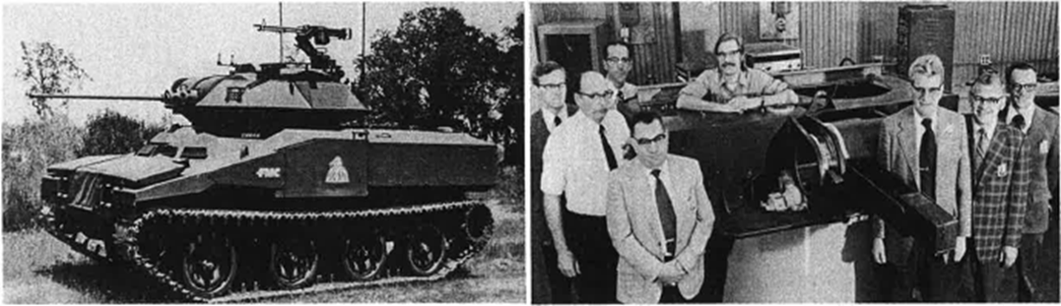

**Left to Right: Army Scout Reconnaissance Vehicle and Part of the Scout Stabilization Team**

Caption: April 1974 saw the first shipment of gun stabilization systems from Ordinance Systems to the vehicle contractor. The system was installed on the Army’s Scout Reconnaissance Vehicle and was the first of four prototypes to ship.

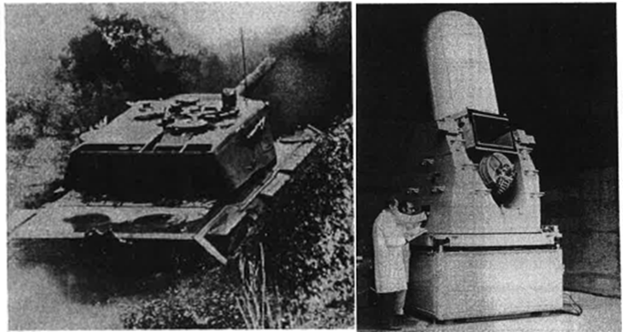

**Left to Right: German Leopard II Battle Tank and the Phalanx Close In Weapon System (CIWS)**

Caption: April 1974 also saw the finalization of an agreement with German manufactures of the Leopard II Battle Tank for Ordinance Systems to produce prototype electric gun and turret power drives. This would be the first all-electric stabilization system for the Leopard series. June of 1974 saw Ordinance Systems received a contract from General Dynamics for production engineering work on the Phalanx CIWS that eventually produced six operational models for testing by the US Navy.

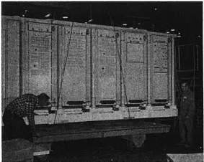

**First Trident Mk 88 Fire Control System**

Caption: April 1975 saw the shipment of the first Trident Mk 88 Fire Control System to be used in test firings of Trident missiles. The parts had to be shipped pre-assembled and were lifted onto a flat-bed truck at Ordinance Plant #1 prior to shipment.

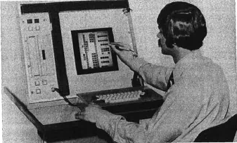

First Computer Based Training System (CBTS) Terminal

Caption: April 1976 saw the contract win to develop 15 CBTS terminals to train the Navy on proper use of the Trident Missile systems. Ordinance would have the responsibility for overall implementation of computer-based instruction in the Trident training systems program.

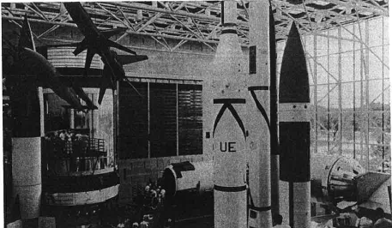

**FBM Exhibit at the National Air and Space Museum in Washington D.C.**

Caption: In July 1976 the recently opened National Air and Space Museum in Washington D.C. opened an FBM exhibit including equipment built in Pittsfield. The products were displayed in the “Space Hall” and included Ordinance Systems Mk 3 Guidance gimbal assembly, a Poseidon Missile, and a cut-away model of the submarine.

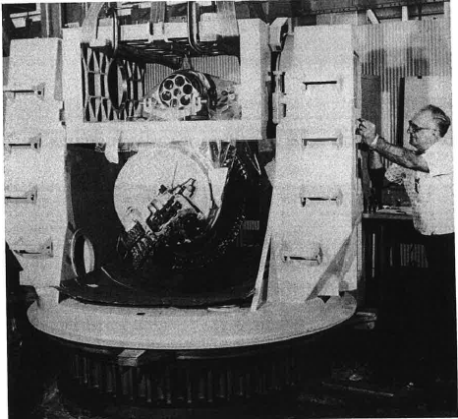

**Phalanx CIWS Mount Prototype**

Caption: December 1977 saw the first Phalanx prototype assembled, tested, and shipped to General Dynamics in California. After a 3-day integration test the installed mount equipment were disassembled prior to shipping.

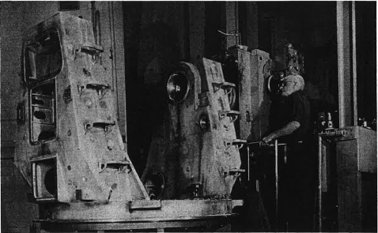

**First Production Phalanx CIWS Mount**

Caption: Following the success of the prototype CIWS development, General Dynamics gave Pittsfield Ordinance Systems to produce, test, and deliver 37 subsystems for the Phalanx CIWS in February 1978. The Phalanx subsystems were assembled in Ordinance Plant #2 which replaced the completed contract for the Mk 45 Gun Mounts.

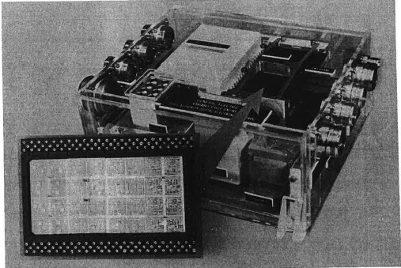

**Hybrid Microelectronic Circuit Board**

Caption: April 1978 saw Ordinance Systems receive a $900,000 contract from GE’s Aircraft Group to design, develop, and construct 23 hybrid microelectronic circuit boards.

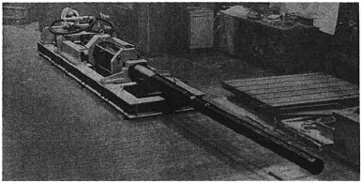

**105mm Liquid Propellant Firing Configuration**

Caption: April 1978 saw Ordinance Systems receive a $1.4 million for a 30 month contract to design, develop, and test a liquid propellant loading and firing configuration of a 105mm test fixture.

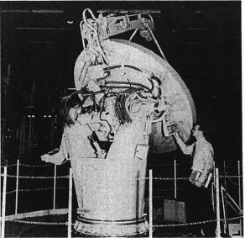

**Prototype Mk 80 Lightweight AEGIS Gun Director**

Caption: May 1978 saw Ordinance Systems receive a $6.5 million contract from Raytheon to produce four lightweight directors for the AEGIS Weapon System.

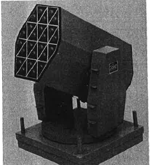

**Concept Model for RAM Launcher**

Caption: June 1978 saw the start of work on an engineering model for the Rolling Airframe Missile (RAM) system for the US and German Navies with General Dynamics as the prime contractor.

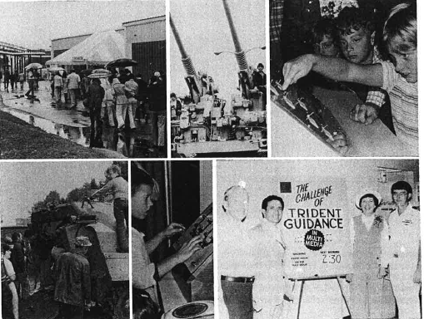

**Family Day 1978 Open House**

Caption: More than 16,000 employees, families, and friends visited Ordinance Systems during Family Day in September 1978. Various exhibits, demonstrations, and presentations were shown and souvenirs and door prizes were given. A special science tour for students with hearing impairments were also given during the event.

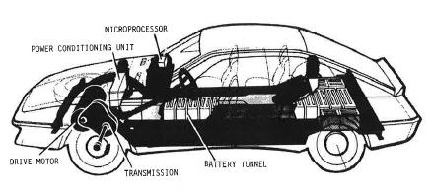

**Prototype Electric Car**

Caption: The US Government’s Department of Energy official unveiled an advanced electric car in June 1979. While primary research and development occurred at GE’s Research Center in Schenectady, New York, GE Pittsfield packaged the electrical control for the car. Other contractors on the project included Chrysler and Globe Union.

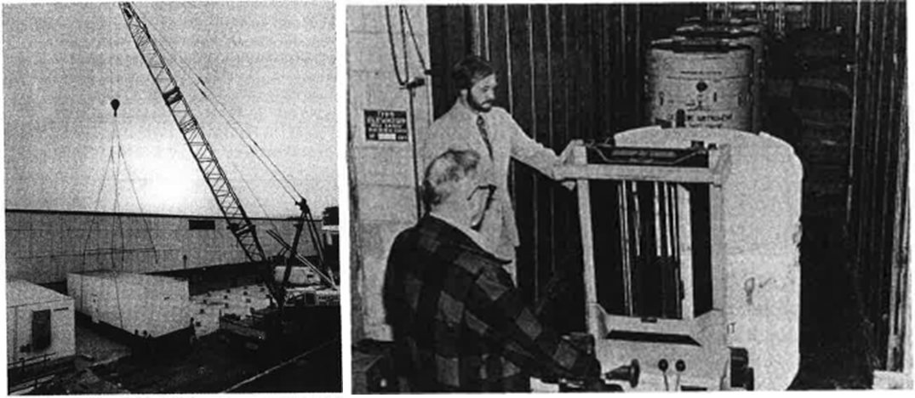

Left to Right: Ordinance Plant #2 Expansion and Guidance Shipment Packaging

Caption: 1979 also saw an expansion of production for guidance equipment. For the second time in 1979 Ordinance Plant #3 tripled their production schedules as a result of component problems elsewhere in the Navy’s network. This caused long schedules and shortages in small items such as shipping containers to meet the deadlines. Ordinance Plan #2 also saw the installation of 20 mobile trailers alongside the west side of the plant. A giant crane had to hoist the trailers into place.

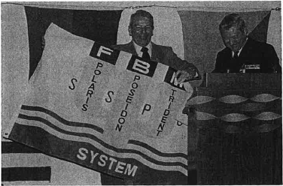

**Rear Admiral Clark Presents the Trident Flag to GE**

Caption: Rear Admiral Clark presented GE with the Trident Flag in January of 1980 as part of a ceremony recognizing the Trident I missile system as the most successful development program in the history of the FBM program.

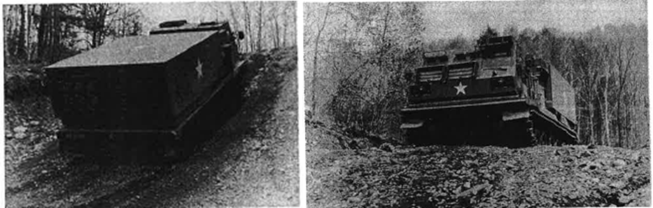

**New Multiple Launch Rocket System (MLRS)**

Caption: March 1980 saw the testing of the first new MLRS with Ordinance System’s special instrumented transmission installed. The test occurred for 6 weeks at the test track in Dalton-Hinsdale.

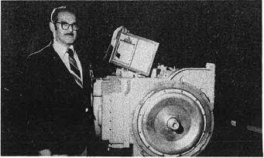

**New 600-HP Transmission**

Caption: In July 1980, Ordinance Systems announced that it was building prototypes of an advanced transmission rated at 600 horsepower. The improved version called, HMPT-500-3, was intended to be installed in future combat vehicles in the years to come.

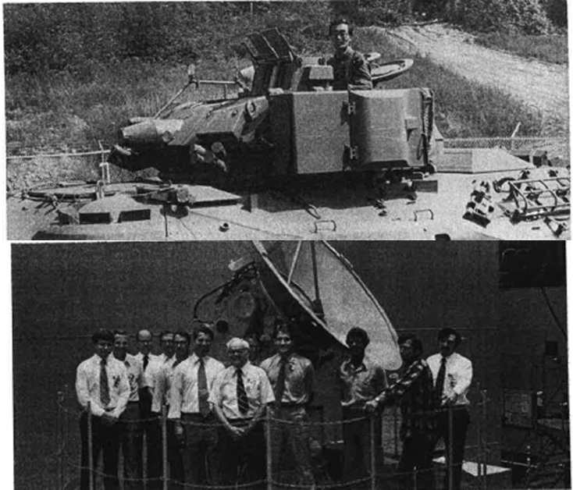

**Top to Bottom: XM-3 Calvary Vehicle and AEGIS Director Team**

Caption: August 1980 saw production beginning on new transmissions and electric turret stabilization systems for US Army Fighting Vehicle programs in Buildings 33 and 63. Japanese Industrialists toured the site to check out potential applications of the Ordinance System’s design for the Japanese Infantry Combat Vehicle. September 1980 saw the final acceptance test on the fourth and final unit of the first AEGIS Director production contract. The four directors were slated to be installed on the USS Ticonderoga (CG 47) as the first ship to receive the new AEGIS air defense system.

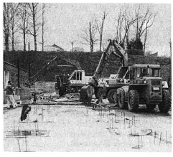

**Ordinance Plant #2 Adds Six More Trailers**

Caption: November 1980 saw the addition of six more trailers along the east side of Ordinance Plant #2 providing some 3,800 square feet of engineering office space.

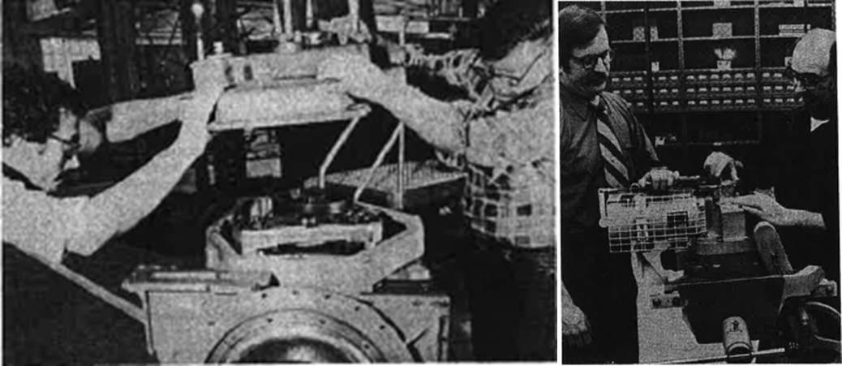

**Transmission Production**

Caption: The first production transmission and turret stabilization systems for the US Army Fighting Vehicles were accepted by the Army at Ordinance Systems production facilities in January 1981. Going into production required converting and equipping some 150,000 square feet of production space in two former Transformer buildings.

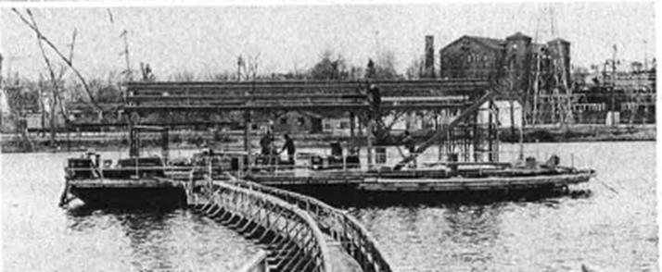

**Silver Lake Barge Dismantled**

Caption: March 1981 saw the dismantling of the Silver Lake barge after which it was turned over to the Department of Labor where it was reassembled in Stoughton, Massachusetts as a training site.

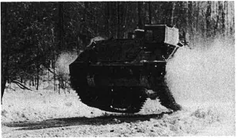

**600 Horse Power Transmission Testing**

Caption: After $1.5 million over the previous 2 years spent on developing the new 600 horse power transmission testing began at test courses in the Berkshires. The transmission was loaded onto a 50,000 pound test vehicle which literally left the ground as it attacked the rough terrain test course at 40mph.

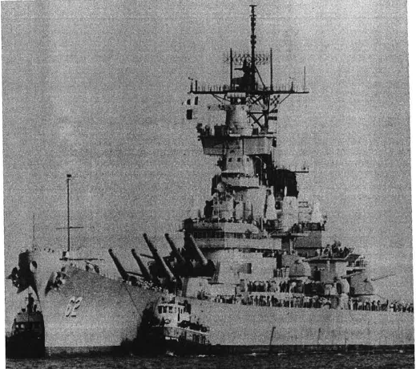

**USS New Jersey**

Caption: By 1982 the US Navy began to upgrade old WWII Battleships and have them rejoin the fleet. In February 1982, Ordinance Systems received a contract for modernization work on the USS New Jersey and USS Iowa. The work involved turret and mount components for the 16” and 5” guns as well as the director control components for the Mk 37 and Mk 38 gun fire control systems.

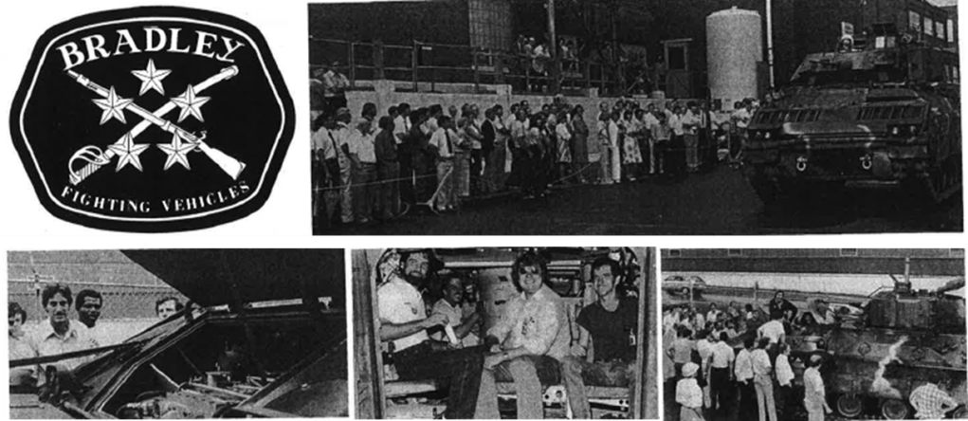

Bradley Fighting Vehicle Production

Caption: In July 1982, Ordinance Systems received its first production-model Bradley Fighting Vehicle for engineering tests on the Dalton-Hinsdale test track. The tests were intended to test the Ordinance Systems hydro-mechanical transmission and electric stabilization systems. By August, 250 to 300 people lined the south wall of Building 33 to watch the Bradley drive alongside the building. Both 1st and 2nd shift production crews, as well as engineering and other office staffs, saw and inspected the vehicle.

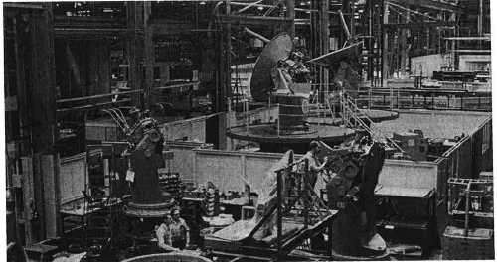

**AEGIS Gun Directors Double Production**

Caption: November 1982 saw the doubling of production for the AEGIS Gun Directors.